

**Figure 1. Workflow for the calculation of the connectivity measures from fMRI resting-state data. A)** After a standard pre-processing pipeline, a parcellation covering the whole-brain is applied-each color represents one anatomical subsystem- to extract BOLD time series (116 ROIs for AAL parcellation, and 66 ROIs for Hagmann parcellation). Here we consider two versions of functional connectivity: the classical corrFC corresponding to the Pearson correlation between pairs of time series; and FC0 and FC1, where the matrix elements are the covariances without (blue arrows) and with (blue) time shift, respectively; see Methods for the detail of the calculation. **B)** Whole-brain network model to interpret fMRI data. The local fluctuating activity ( where Σii represents the variance for region i) propagates via the recurrent EC to generate the correlation patterns at the network level. Structural connectivity (SC, bottom) obtained using diffusion-weight imaging (DWI) determines the skeleton of EC. The estimation procedure iteratively tunes EC and Σ such that the model best reproduces the empirical FC (FC0 and FC1). **C)** The corrFC matrices have 116x116 elements, it is symmetric and has diagonal elements all equal to 1, so only the 6670 independent links in the lower triangle are retained for identification/classification. Likewise, the EC matrix has 4056 non-zero elements that are considered for classification (density of 30%).

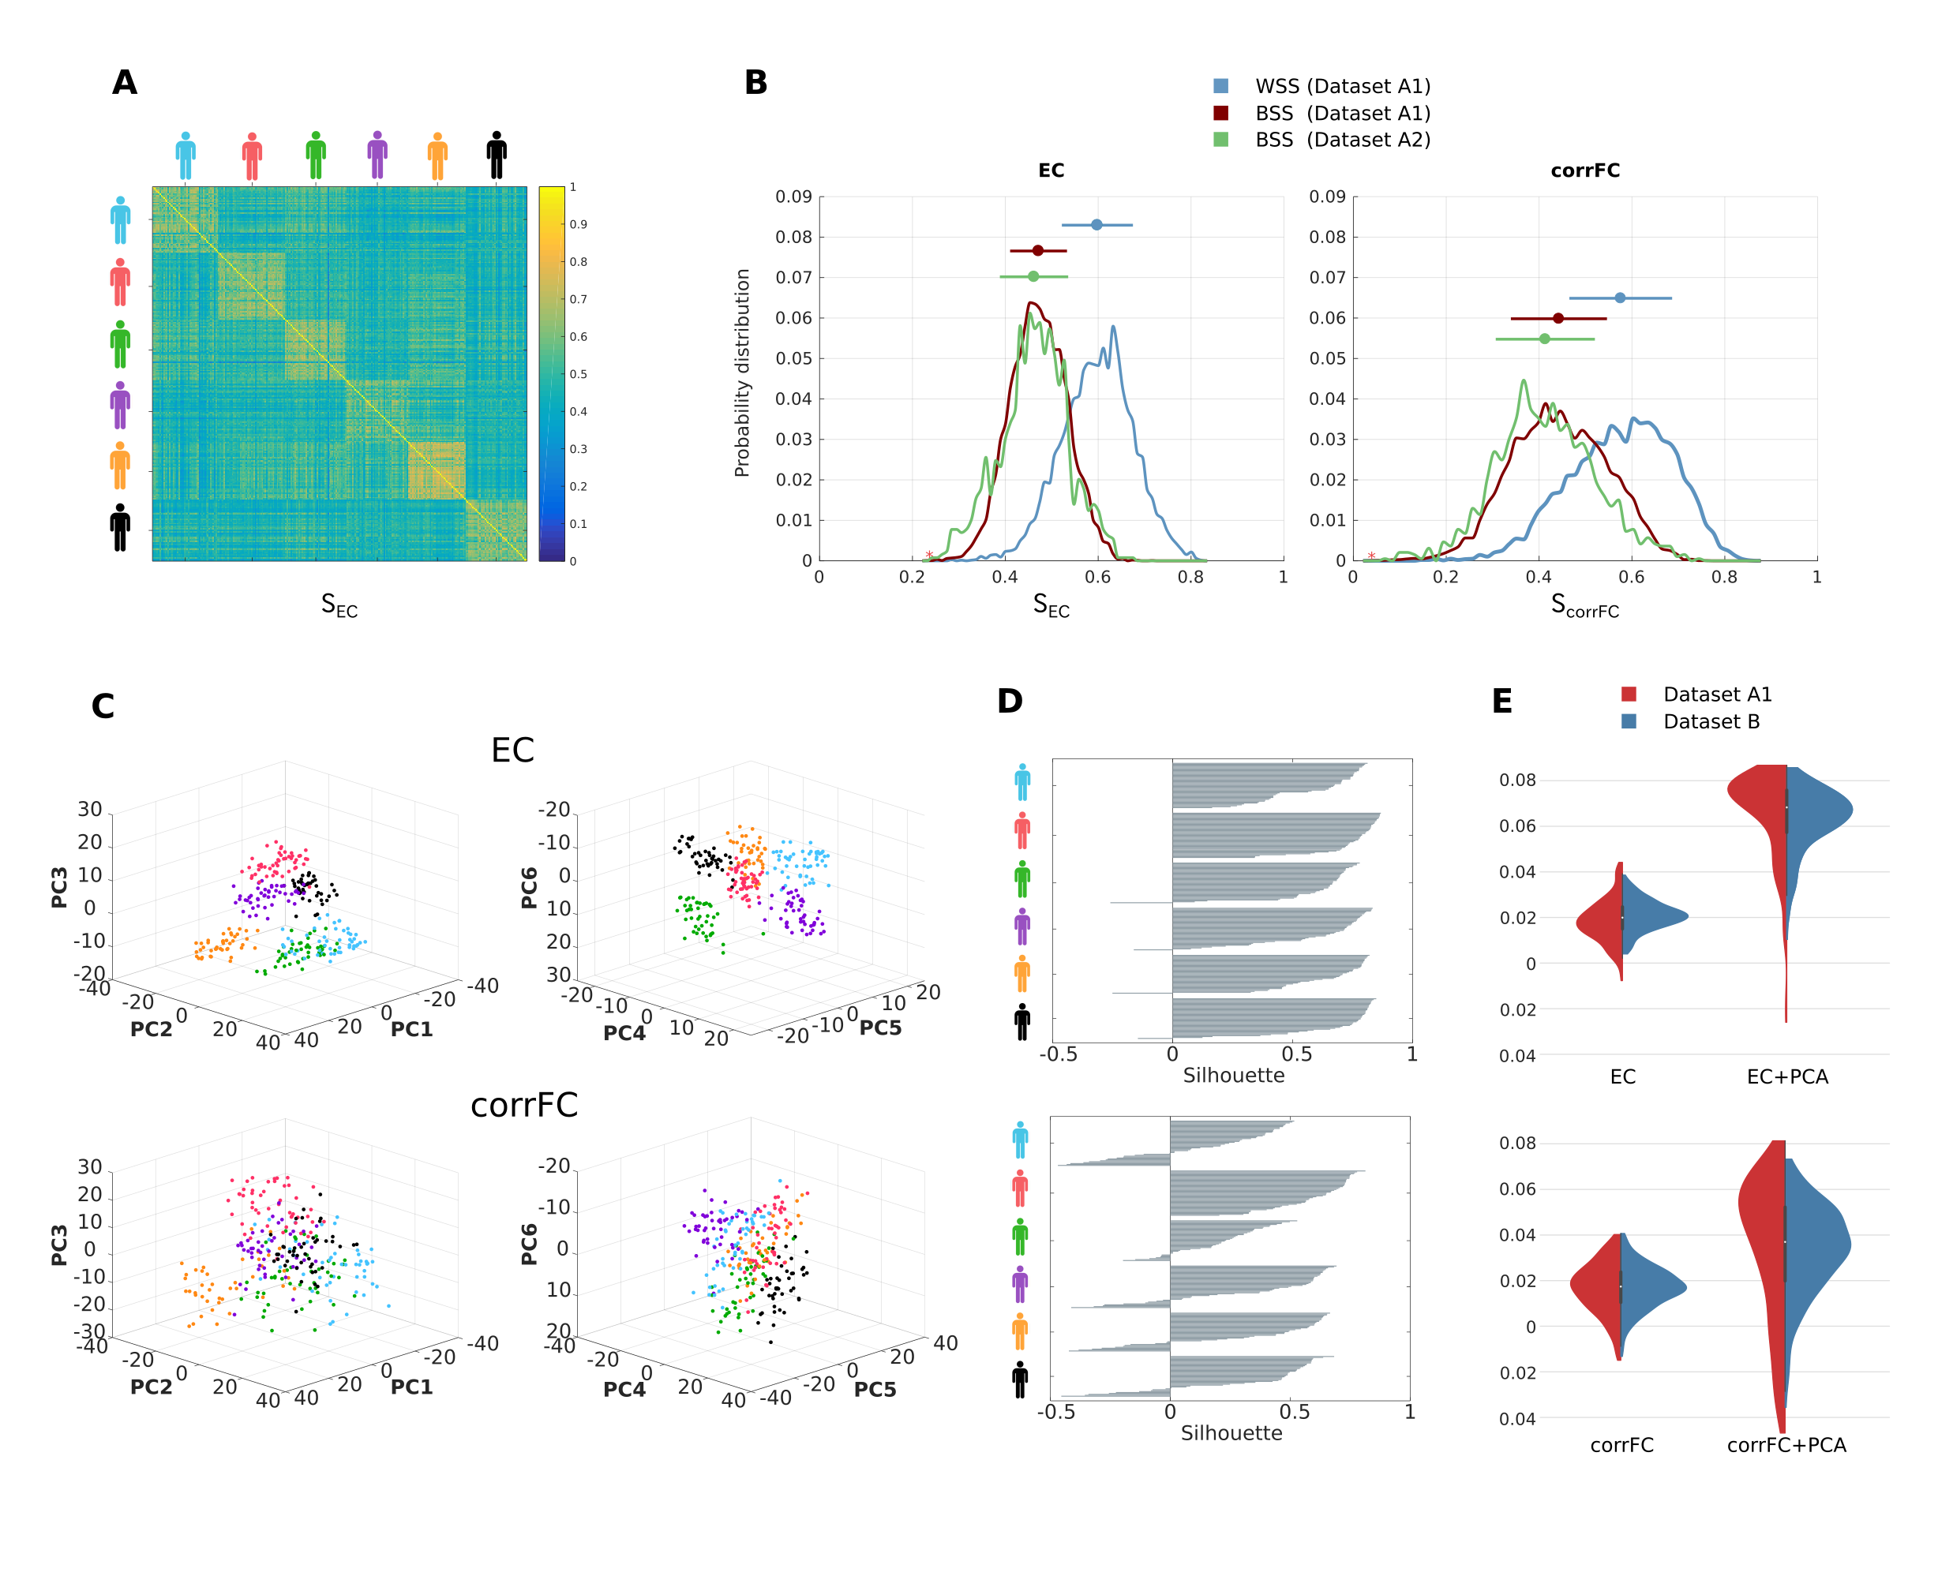

**Figure 2. Within- and between-subject similarity (WSS and BSS, respectively) for EC and corrFC. A)** Matrix of Pearson correlation coefficient (PCC) values for EC between all pairs of sessions from Dataset A1. ECs from two sessions are transformed into two vectors, from which similarity is calculated (SEC); the sessions are grouped by subjects, as indicated by the colored symbols. **B)** Distributions of WSS (blue) and BSS (red) similarity values for Datasets A1 – corresponding to diagonal and off-diagonal in panel A, respectively – and of BSS (green) for Dataset A2. Dots and lines on the top represent means and standard deviation respectively. **C)** Visualization of the sessions of Dataset A1 in the space of the first 6 PCs obtained from PCAof EC (top row) and corrFC (bottom row). Each point corresponds to a scan session and subjects' identity is colorcoded as in panel A. **D)** Silhouette coefficients of each session in panel C (see Eq. 16 in Methods and text for details). **E)** Distribution of the silhouette coefficients for EC (top panel) and corrFC (bottom panel), for original link space (left) and for the space of first 6 PCs (right). Both Datasets A1 (6 subjects, in red) and B (30 subjects, in blue) are represented by withviolin plots. After applying PCA, silhouette coefficients of EC are higher than corrFC.

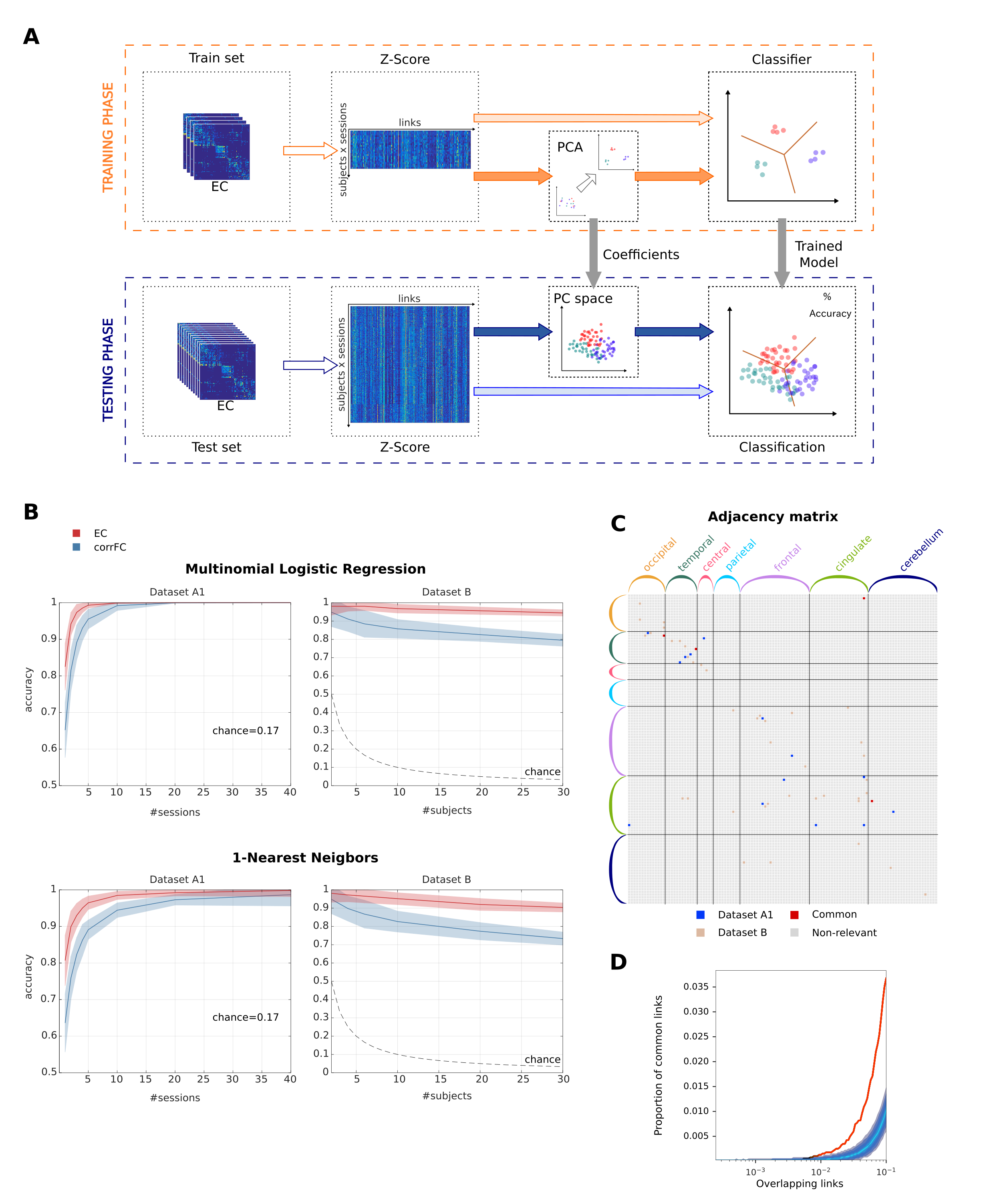

**Figure 3. Classification performance of EC and FC depending on sessions and subjects. A)** Classification pipeline used to assess the performance on subject identification. The full set of connectivity measures (here EC) over all fMRI sessions was split into two groups: a train set and a test set. We applied a z-score standardization for the elements of each session matrix (see Eq. 12 in Methods). We trained the classifier – with or without applying PCA – and evaluated the classification accuracy on the test set. **B)** Performance of Multinomial Logistic Regression (MLR) and 1-Nearest Neighbor (1-NN) classifiers increasing the number of sessions per subject used on the train set (left panels) with Dataset A1 (6 subjects with about 50 sessions each). The mean (solid curve) and standard deviation (colored area) were calculated for 100 repetitions with cross-validation. Performance when varying the number of subjects using a single xxx RECHECK training session per subject (right panels) with dataset B (30 subjects with 10 sessions each). **C)** Extracted links that contribute to the classification of subjects with both datasets after applying Feature Recursive Elimination (FRE). **D)** Proportion of common links between datasets A1 and B as a function of selected links (in the order of RFE rankings). Curve represents the amount of common links in the data. The shaded area represent different quantiles of the distribution of common links under the null-hypothesis of random rankings.

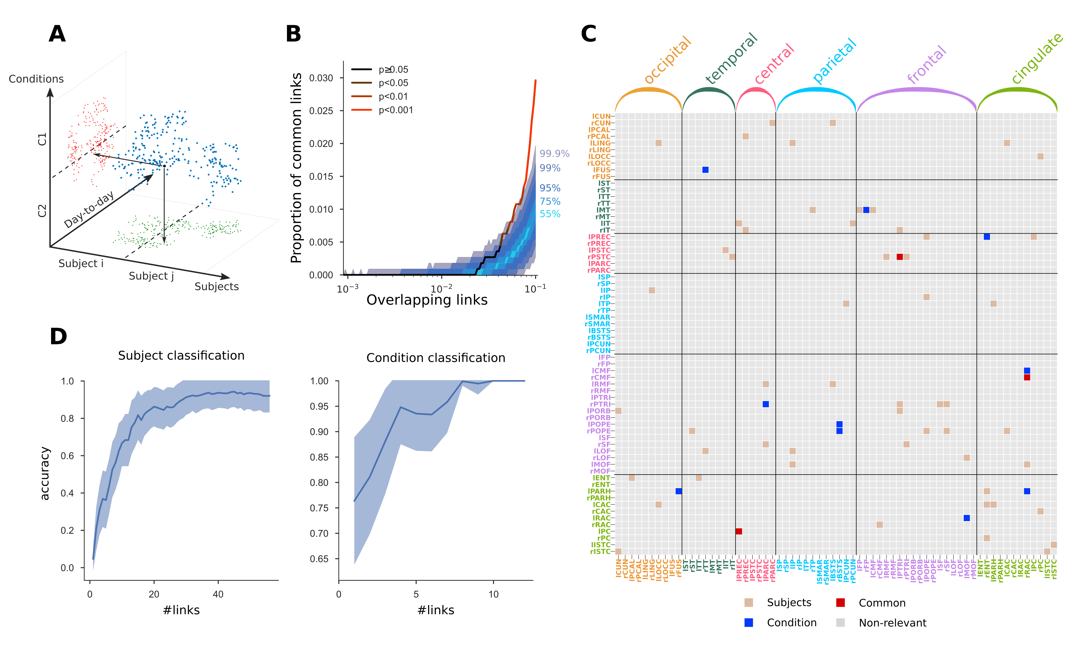

**Figure 4. Two-fold discrimination between subjects and conditions using EC.   
A)** Scheme of the bi-dimensional approach used for identifying both the signature of each condition and the fingerprint of the subjects. **B)** Proportion of common links between the classification subjects and conditions as a function of selected links (in the order of RFE rankings). Curve represents the amount of common links in the data. The shaded area represent different quantiles of the distribution of common links under the null-hypothesis of random rankings. The color of the curve represents the p-value under the null-hypothesis. **C)** Most discriminant connectivity links from EC that drive the classification between subjects and between conditions from Dataset C (X links for subject classification in brown, X for condition classification in blue, 3 common links for both kinds of classification in red). RFE was applied to find the most relevant connections between ROI for bi-dimensional discrimination between subjects and conditions. **D)** Proportion of common links between subjects and condition classification (Dataset C) as a function of selected links (in the order of RFE rankings). Same conventions as in C.

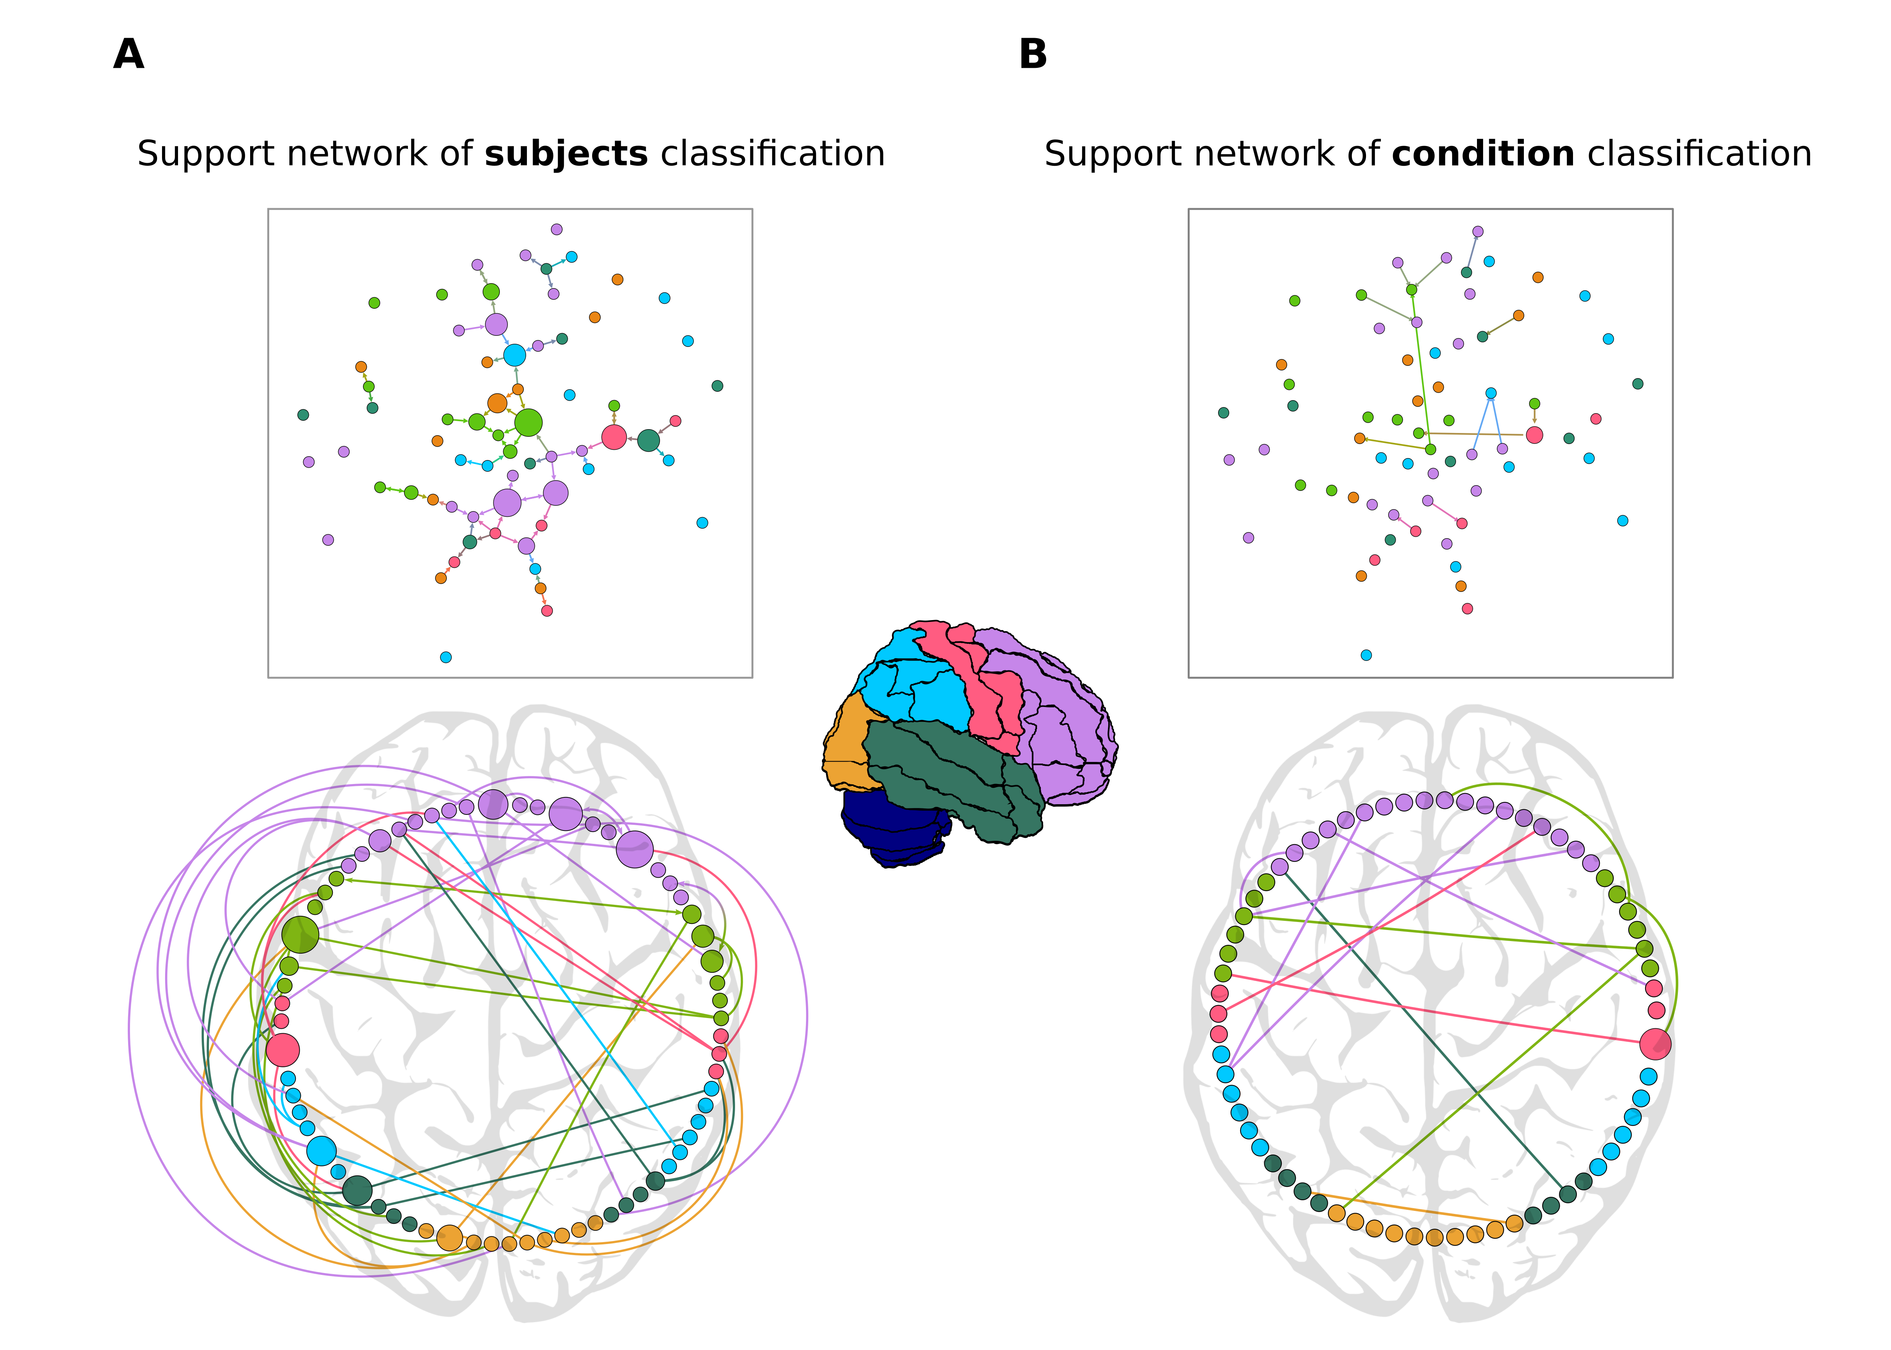

**Figure 5. Support networks of subject and condition classification. A)** Graph plot of the X most discriminant EC links supporting the classification of subjects. The size of each node represents its betweeness centrality from the extracted network. The most central regions are located mainly in the frontal cortex. The circular plot shows the asymmetry and lateralization of the network, with more links located in the left hemisphere (CHECK). Links that are inside the circle correspond to contralateral connections, while links outside the circle are the ipsilateral connections. **B)** Graph and circular plot of the X extracted links that support the classification between conditions (resting vs. movie). Fewer links are required to reach high accuracy in the discrimination between conditions.